
Report Development – A Worked Example
March 2006

Purpose and Audience
This document provides a worked example of a report development task.

It should be read by anyone intending to develop ediEnterprise reports.

Prerequisite reading
It’s recommended that the reader read Report Development - An Introduction.doc this will provide…

- an introduction to ediEnterprise,
- instructions on navigating to the reporting menus and
- an introduction to report development.

The reader should also read Report Development – Working with the Database.doc for details on ediEnterprise database conventions and practices and Report Development – Discovery and Error Correction.doc for details on the discovery process.

The task

A common report development task is the addition of extra columns to an existing report.

Operations->Forwarding->Reports->Shipment Profile Report is a simple listing of shipments with supporting information.

Comparing the report to the Shipment screen it can be seen that the Service Level and INCOTERM fields (highlighted in Figure 1) have not been included in the Shipment Profile Report.

The task is to add these fields to the shipment profile report. As discussed in Report Development – An Introduction all report development is essentially the task of modifying a report template and\or it’s data sources. This task will involve the following specific steps…

- Locate and make a copy of the template used by the Shipment profile report
- Determine which data source the template uses
- Determine which database fields the Service level and INCOTERM are stored in
- Add those fields to the template’s data source
- Modify the template to display the new fields
- Create a new menu item so the modified template can be used

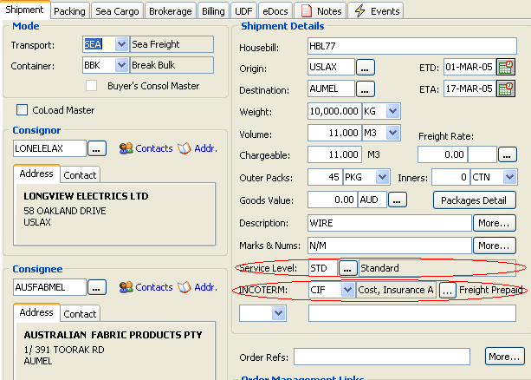
Figure 1

Locate and make a copy of the template used by the Shipment profile report

The easiest way to determine which template a report uses is to navigate to the customize reports screen. To do this…

- navigate to the module report menu that the report belongs to, in this case Operations->Forwarding->Reports.
- Right click on the Reports grid to access the Customise Reports screen using the Customise Reports popup menu.

Figure 2 illustrates these steps.
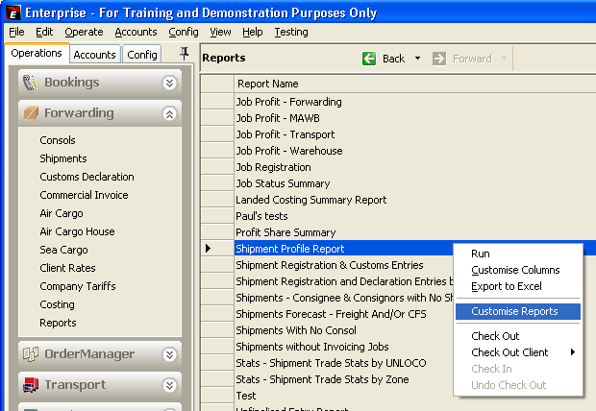
Figure 2

As can be seen in Figure 3 the report customisation screen has 3 grids.

The top grid, the reports grid, contains the menu name for a given report, the other columns are not significant at this stage.

Clicking on a particular menu title in the Reports grid will populate the Templates Used grid with the template details. As highlighted in Figure 3 this tells us which template is used. In this case it is the Shipment Profile Report template that this report uses.

All templates that are defined as system (See the system column of the Available Templates grid shown in Figure 3) cannot be edited or viewed directly, instead the developer must make a copy of the template to view it.

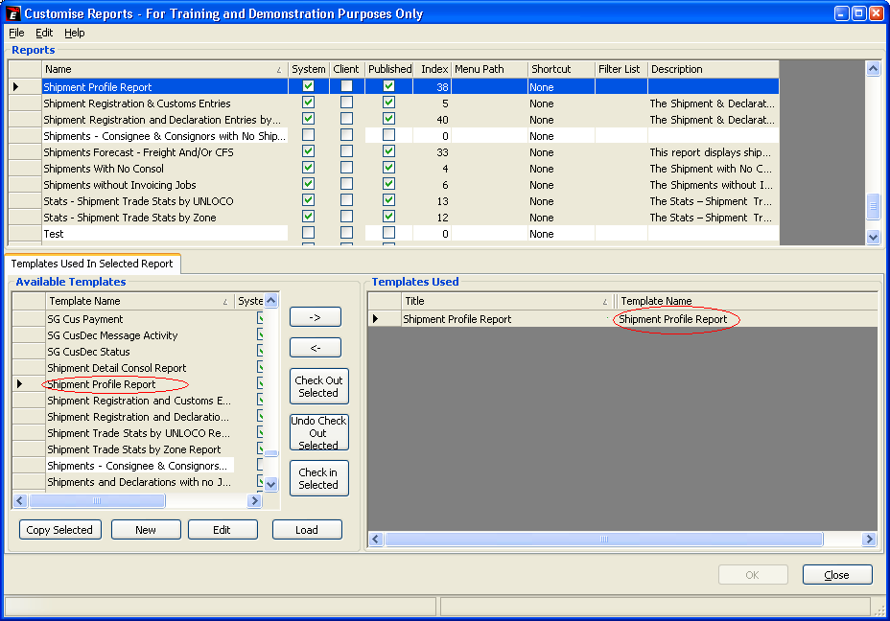
Figure 3

As shown in Figure 4 highlighting the template in the Available Templates grid and hitting the Copy Selected button will make a copy of the selected template.

Having done this hitting the Edit button will display the Excel template.

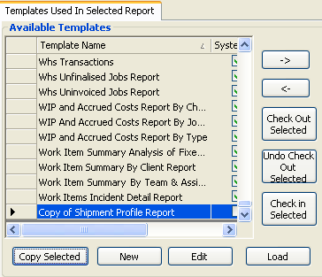
Figure 4

Determine which data source the template uses

Hitting the edit button (Shown in figure 4) will open the template for editing.

Figure 5 shows a portion of the Shipment profile template (Ignoring the columns to the right, what can be seen would in fact be sufficient to run the report).

Column A of all reports is a meta data column containing specification information that will not be shown in the rendered template.

Templates can have several Sections. Sections are defined in column A and as can be seen in Figure 5 the Shipment profile template has a Config, DocumentHeader and SectionBody section with and endofreport marker delimiting the last section.

At a minimum a template must have a Config and SectionBody section.

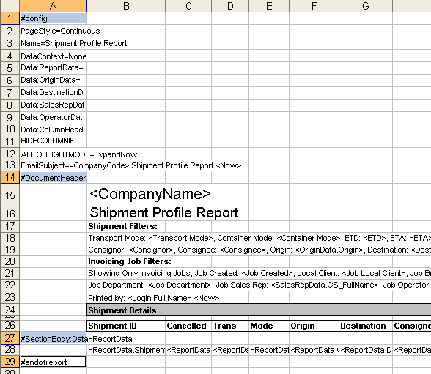
Figure 5

As is probably clear the Config section contains report setting and definitions of the reports data sources.

The main data source for a report is the one associated with the SectionBody. As can be seen from figure 5 the ReportData data source is the main data source for this template.

As shown in Figure 6, looking back to the Config section for the definition of the ReportData data source reveals that vw_Report_ShipmentProfileReport is the view we will need to modify.

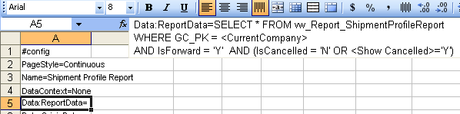
Figure 6

Determine which database fields the Service level and INCOTERM are stored in

As detailed in Report Development – Discovery and Error Correction ediEnterprise incorporates a tool that enables developers to determine which database fields a data entry control on an ediEnterprise form is related to.

The tool is simple to use. Click into the data entry control and hit the Control, Alt and R keys simultaneously.

Doing so for Service level and INCOTERM produces the results shown in Figures 7 and 8 respectively.

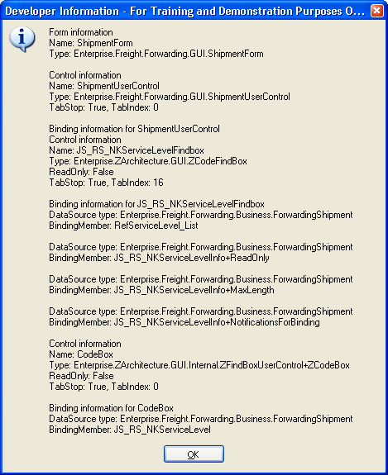
Figure 7

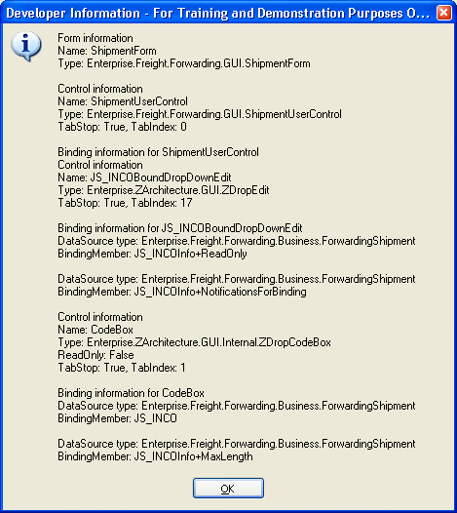
Figure 8

As can be seen service level is stored in the field JS_RS_NKServiceLevel and INCOTERM is stored in the field JS_INCO.

If the reader is familiar with ediEnterprise database naming conventions several important facts will be evident form these names.

Firstly the prefix JS_ indicates that both fields are stored on the JobShipment table. As this is the shipment screen this is probably not surprising however the shipment screen shows shipment details as well as shipment related details for example the Equipment field on the Pickup tab of the Shipment screen is related to JP_FCLPickupEquipmentNeeded which is a field on the JobDocsAndCartage table.

Secondly the RS_ tells us that the JS_RS_NKServiceLevel is actually a foreign key to the RefServiceLevel table however the NK tells us that it’s a natural ( readable code ) foreign key so when we come to modify the view vw_Report_ShipmentProfileReport we could use this field as is or we could join RefServiceLevel for a more detailed description.

Add those fields to the template’s data source

The views SQL now needs to be modified to return the two new fields. Some developers will have copies of ediEnterprise scripts on disk other may need to extract the SQL from the database.

Running the command sp_HelpText vw_Report_ShipmentProfileReport on and ediEnterprise database will return the SQL for this view.

The full text of this view is too large to include here. It’s recommended that the user extracts the SQL from an ediEnterprise database for themselves in order to understand the following material.
Observant readers may notice that the query doesn’t conform to the conventions detailed in Report Development - SQL Development Style Guide.doc. That’s because they are new and being applied as new work is done, not retrospectively.

As can be seen the view is quite complex but (assuming we’re happy with the Service Level code not the longer description held on the RefServiceLevel table) the task here is quite simple, select the two new fields from the central table of this view (JobShipment). So adding the following to the select and group by lists is sufficient…

JS.JS_RS_NKServiceLevel,
JS.JS_INCO,

Modify the template to display the new fields

For this task the template modification simply requires the insertion of two new columns, the specification of a name for each and the specification of the new fields in the SectionBody.

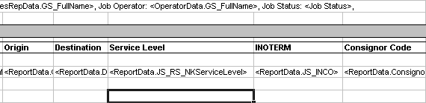
Figure 9

As can be seen in Figure 9, the new columns have been inserted between Destination and Consignor Code (Shown in their original format in Figure 5). The columns have been deliberately widened to show the data source specification, in reality the developer would set these columns to a width that is appropriate to the actual data ( in this case both are 3 character codes so the column would probably only be as large as their headings.

Having made these changes save the excel file and hit the OK button on the message shown in Figure 10.

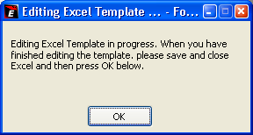
Figure 10

Create a new menu item so the modified template can be used

The report is now modified and all that remains is to create a menu item from which it can be run.

This is as simple as adding a new item at the bottom Reports Grid on the Customise Reports Form (Shown in Figure 3), highlight the template and hit the -> button to associate the template with the new menu item. Figure 11 shows this.

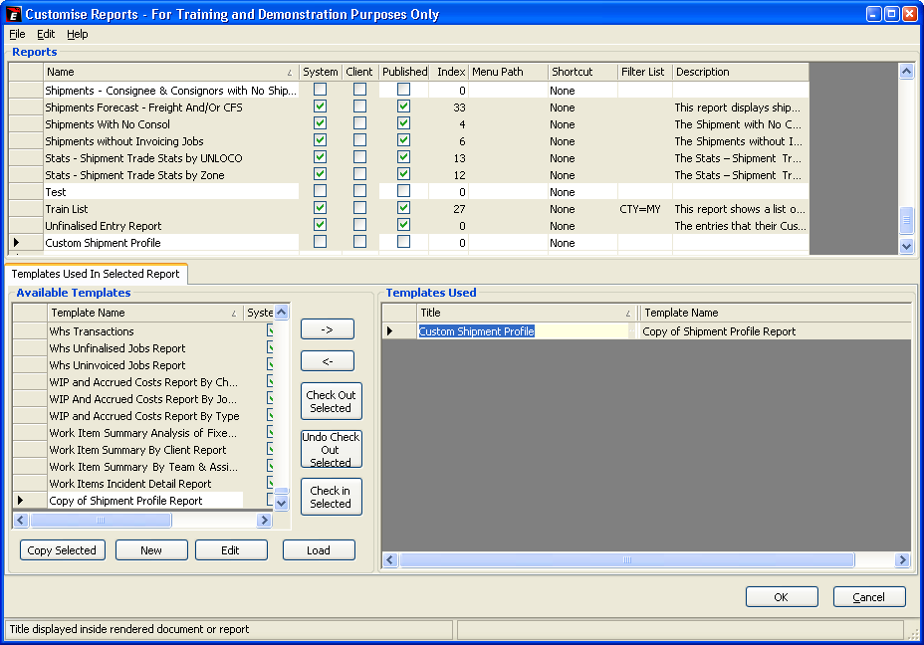
Figure 11

Hitting the ok button will now save all those changes and make the menu available in the Forwarding->Reports screen.

Figure 12 shows an extract of the results.

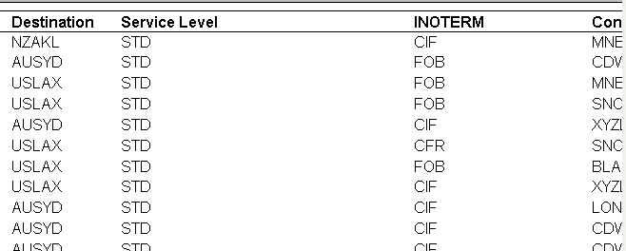
Figure 12

The task is complete.

What to do next and Further Reading
Readers should be ready to begin a simple report development task.

Some useful information can be found in the document Report Development – Discovery and Error Correction.doc which describes a tool that allow a developer to discover the names of database fields using the ediEnterprise application and details common report development errors and their solutions.

